Fire Protection
Name:
Institution

Fire Protection
Fire protection is the practice of mitigating harmful consequences of fire through compartmentalization, suppression and coming up with reliable mitigating systems. Fire protection in fire resistive, combustible, and non-combustible houses is achieved through passive and active fire protection.
Passive fire protection involves electing fire barriers such as firewalls and fire rated floors to limit the spread of fire, smoke, and high temperatures.
Active fire protection requires the installation of manual and automatic fire detection and suppression systems to prevent spreading of fire once the ignition is detected.
In designing of any fire protection system factors such as building occupancy, building use, and installed systems are considered to determine the appropriate system to fit. The goals of a typical fire protection are to save lives, protect property and preserve business continuity.
Fire protection systems installed in fire resistive, combustible, and non-combustible houses achieves these goals through the following
Detection system
Detection systems include integrated sensors fitted in different locations within the building to pick up signals of any developing fire situation. Notably, smoke detections systems sense smoke from a developing fire triggering alarm, notification system, and fire suppression system if necessary. On the other hand, heat detection systems are designed to pick up the sign of fire even before smoke develops triggering alarm, warning system, and fire suppression system if necessary.

Alarm and warning system
Alarm and notification systems are responsible for alerting building occupants of a fire situation and providing specific instructions on how to vacate the building for their safety. This system also alerts police and firefighters in the stations of the location of the fire to initiate a response. In some cases, alarm system is designed to close fire doors, and recall elevators to increase the safety of the occupants from the fire hazard.
Suppression system
Fire suppression systems are purposely designed to extinguish and prevent the spread of fire in a building to save life and prevent property damage. Water sprinklers are more common in the occupied building where they dispense pressured water jets in the location of the fire. Each sprinkler head is fitted with a heat-sensing element that overheats in the case of fire activating sprinkler.
In the case where water can cause damage to sensitive equipment’s and electronics, gaseous and chemical suppressions are used to put out the fire. Detection, fire suppression, alarm and notification systems need to be well integrated to work together efficiently in the building to save life and protect property.
Automatic Fire Suppression System
Automatic fire suppression system is a fire mitigation system designed to extinguish and control fire in a building without manual human intervention. The purpose of this scheme is to provide full control of fire situations automatically without the need for human input and monitoring.
Automatic fire suppression systems are categorized as engineered and pre-engineered systems. Engineered automatic fire suppression systems are specifically designed for a particular purpose. Pre-engineered fire suppression system combines pre-designed elements resulting to no need for engineering tasks over product design.
Automatic fire suppression system consist of the following components:
Control panel – it continuously monitors functioning of the system and gives indications of fire occurrence.
Detection network – it consists of integrated smoke and heat sensors that pick up signs of fire and give a signal to control panel.
The main cylinder – it stores the fire-extinguishing agent that is in the form of dry powder or gas.
Actuation device – it is an electromechanical device that received a relay signal from the control panel to actuate valves on the main cylinder and expellent cartridge.
Expellant cartridge - contains pressurized gas that fluidizes extinguishing agent as it flows from the main cylinder to the nozzles.
Delivery system – this consist of double wire braided high-pressure hoses with strategically located nozzles to deliver the extinguishing agent suppressing the fire.
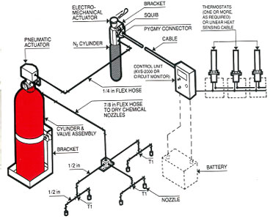
Figure 1: Automatic fire suppression system
Automatic fire suppression system uses different types of extinguishing agents depending on nature of the fire hazard and use of the building. The following are examples of automatic fire suppression system.
Dry chemical powder suppression system directly introduces a chemical powder into the fire extinguishing it. They are widely applied in the area prone to fire hazard from bulk chemicals and liquefied gasses.
Fire sprinkler system makes us of water sprinkler jets that produce excellent spray over the fire prevent fire outbreak. Fire sprinklers connect to a piping distribution system, which in turn connect to water supply mains.
Gaseous fire suppression system makes us of a chemical gas agent to put out the fire. This system deploys rapidly and does not cause and damage to property making it suitable for application in high-value asset buildings.
Firefighter benefits from automatic fire suppression system since the system brings fire in control preventing fire spread before the firefighter respond. This gives the firefighters enough time to prepare and move to the fire location before the fire causes severe property damage or loss of lives.
Fire Hydrant
A fire hydrant is a connection point to pressurized water system by which firefighters can tap to by fastening a hose on the nozzles of the hydrant. Considering the case under study, the most suitable hydrant is a wet barrel fire hydrant.
The reason for selecting wet barrel fire hydrant because of their simple construction and easy accessibility. Also, the valves and nozzles on the hydrant operated independently making wet barrel fire hydrant more flexible in operation.
The following tests are performed on a wet barrel fire hydrant
Pressure Testing
Pressure testing on a wet barrel hydrant is done in the following steps
1. One of the hose caps is removed and the hydrant slowly filled with water.
2. Hydrant Test cap with gauge is installed, and the remaining air breeds out.
3. With the nozzle caps tightly locked, the hydrant is open to full line pressure.
4. If a higher test pressure is needed (max. 200 PSI working pressure), a pressure test pump is connected to the hydrant’s Pumper Nozzle
Drainage Test
Drainage test on wet barrel fire hydrant is performed as follows
1. One of the Hose Caps is removed and the hydrant filled with water.
2. With the hydrant in the closed position and palm of one hand placed over the open Hose, a noticeable vacuum should be felt indicating proper drainage of the hydrant.
Hydrant Flow Testing
The nozzle cap on the pressure hydrant is removed and a pressure gauge attached to the outlet.
The valve on the hydrant is completely opened; making sure the path of flow to the drain or pathway is safe and clear
Residual pressure from the pressure hydrant gauge is recorded after the pressure needle stabilizes.
The hydrant is slowly closed to avoid undue surges, which can cause damage and returned to operational condition.
Maintenance of Fire Hydrant
During maintenance of wet barrel fire hydrant, the following should be performed
O-rings and head gaskets should be replaced annually and the head mechanism well lubricated with food grade oil. Replacement of pumpers and nozzles should be done immediately the damaged nozzle or pumper is identified.
The paint on the hydrant should be maintained in good condition with an appropriate color code. All outlets should be maintained clean and threads lubricated. Operating nut should be checked to ensure it is not rounded due to use of wrench in place of hydrant key and replaced if the case.
Hydrants need a clear distance around to enable a hydrant wrench to be swung 360 degrees on any operating nut and cup. The hydrant should have a clear space of one-meter diameter with guard posts place around to prevent damage by vehicles.
The maximum distance to a fire hydrant from the closest point on the building should not exceed 112 meters, and the maximum distance between fire hydrants should not exceed 152 m.
Along the streets, the hydrants should have minimum side’s clearances of 2 meters due to traffic.
.
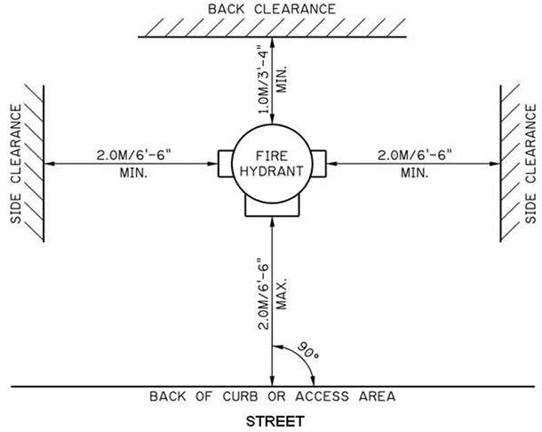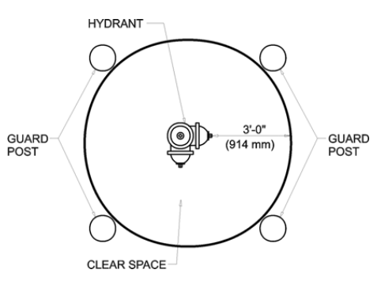
Figure 2: Fire hydrant spacing requirement
During the inspection, the following items are reviewed to ensure proper functioning of the hydrant. The pumper port and the nozzles should be facing the correct directions. The materials surrounding the hydrant should be capable of support it. The color code on the hydrant should be correct. A minimum clearance of 15 inches should be maintained between the lowest point on the hydrant and the ground.

References
- Commissioning of fire hydrant systems: Checklists. (2014). Homebush, N.S.W.: Standards Australia.
- SPRING Singapore. (2013). Code of practice for fire hydrant, rising mains and hose reel systems: Formerly CP 29. Singapore: SPRING Singapore.
- Stevens, R. B., United States., & FMC Corporation. (2013). Automatic fire sensing and suppression systems for mobile mining equipment: Final report. Santa Clara, CA: The Division.
- Sturzenbecker, M. J., Adams, B., Burnside, E., & International Fire Service Training Association. (2010). Fire detection and suppression systems. Stillwater, OK: Fire Protection Publications, Oklahoma State University.
- In Hurley, M. J. (2016). SFPE handbook of fire protection engineering.
- Jones, A. M. (2015). Fire protection systems.
- In Roux, R. J., In Coache, C. D., National Fire Protection Association., & American National Standards Institute. (2015). National fire alarm and signaling code handbook.

